/* PART 2 */

// Initial script

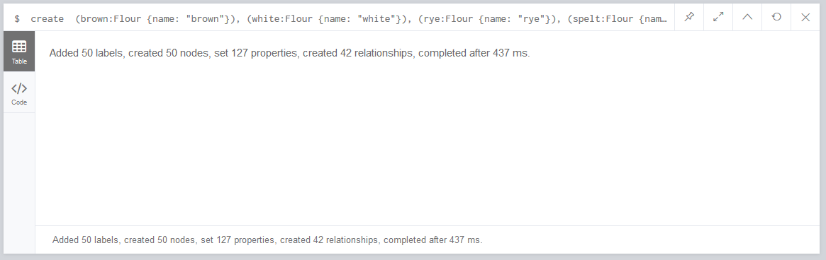

// Create 3 chefs

CREATE

(gordon:Chef { name: 'Gordon Ramsay', title: 'Chef' }),

(alton:Chef { name: 'Alton Brown', title: 'Chef' }),

(mary:Chef { name: 'Mary Berry', title: 'Chef' })

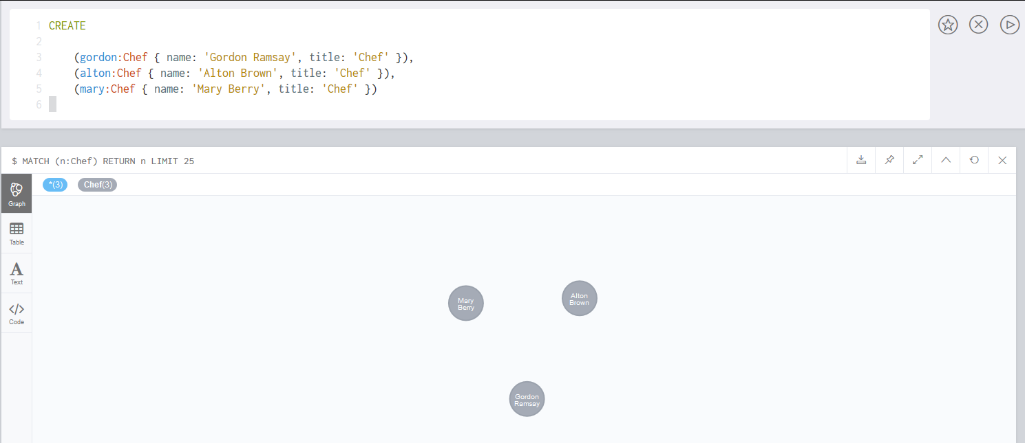

// Creating recipes

CREATE

// Pound Cake

(poundCake:Cake {name: "Pound Cake"}),

(poundCake)-[:CONTAINS {quantity: 400, unit: "grams"}]->(selfraising),

(poundCake)-[:CONTAINS {quantity: .5, unit: "grams"}]->(salt),

(poundCake)-[:CONTAINS {quantity: 160, unit: "grams"}]->(sugar),

(poundCake)-[:CONTAINS {quantity: 300, unit: "grams"}]->(milk),

(poundCake)-[:CONTAINS {quantity: 4, unit: "grams"}]->(egg),

(poundCake)-[:GARNISHED_WITH {how: "poured on top"} ]->(cream),

// Pancakes

(pancakes:Cake {name: "Pancakes"}),

(pancakes)-[:CONTAINS {quantity: 100, unit: "grams"}]->(white),

(pancakes)-[:CONTAINS {quantity: 150, unit: "grams"}]->(brown),

(pancakes)-[:CONTAINS {quantity: .5, unit: "grams"}]->(salt),

(pancakes)-[:CONTAINS {quantity: 80, unit: "grams"}]->(sugar),

(pancakes)-[:CONTAINS {quantity: 300, unit: "grams"}]->(milk),

(pancakes)-[:CONTAINS {quantity: 1, unit: "grams"}]->(egg),

(pancakes)-[:GARNISHED_WITH {how: "sprinkled on top"} ]->(sugar),

// Lemon Cake

(lemonCake:Cake {name: "Lemon Cake"}),

(lemonCake)-[:CONTAINS {quantity: 250, unit: "grams"}]->(selfraising),

(lemonCake)-[:CONTAINS {quantity: 80, unit: "grams"}]->(margarine),

(lemonCake)-[:CONTAINS {quantity: .5, unit: "grams"}]->(salt),

(lemonCake)-[:CONTAINS {quantity: 125, unit: "grams"}]->(sugar),

(lemonCake)-[:CONTAINS {quantity: 100, unit: "grams"}]->(currants),

(lemonCake)-[:CONTAINS {quantity: 100, unit: "grams"}]->(sultanas),

(lemonCake)-[:CONTAINS {quantity: 25, unit: "grams"}]->(brandy),

(lemonCake)-[:CONTAINS {quantity: 3, unit: "grams"}]->(lemon),

(lemonCake)-[:CONTAINS {quantity: .5, unit: "grams"}]->(mixedspice)

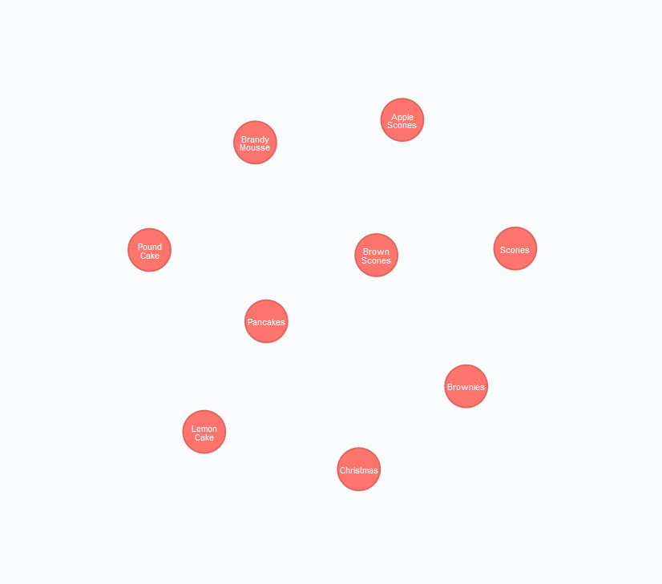

// Creating relationships between chefs and their recipes with popularity property

MATCH (gordon:Chef),(poundCake:Cake)

WHERE gordon.name = 'Gordon Ramsay' AND poundCake.name = 'Pound Cake'

CREATE (gordon)-[r:MAKES {Popularity : 6}]->(poundCake)

RETURN gordon, poundCake;

MATCH (alton:Chef),(pancakes:Cake)

WHERE alton.name = 'Alton Brown' AND pancakes.name = 'Pancakes'

CREATE (alton)-[r:MAKES {Popularity : 9}]->(pancakes)

RETURN alton, pancakes;

MATCH (mary:Chef),(lemonCake:Cake)

WHERE mary.name = 'Mary Berry' AND lemonCake.name = 'Lemon Cake'

CREATE (mary)-[r:MAKES {Popularity : 7}]->(lemonCake)

RETURN mary, lemonCake;

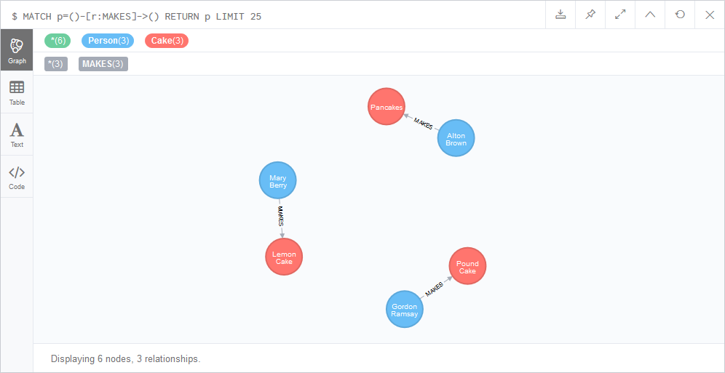

// Match existing cakes to chefs

MATCH (gordon:Chef),(scones:Cake)

WHERE gordon.name = 'Gordon Ramsay' AND scones.name = 'Scones'

CREATE (gordon)-[r:MAKES {Used : 150}]->(scones)

RETURN gordon, scones;

MATCH (alton:Chef),(brownies:Cake)

WHERE alton.name = 'Alton Brown' AND brownies.name = 'Brownies'

CREATE (alton)-[r:MAKES {Used : 210}]->(brownies)

RETURN alton, brownies;

MATCH (alton:Chef),(brownscones:Cake)

WHERE alton.name = 'Alton Brown' AND brownscones.name = 'Brown Scones'

CREATE (alton)-[r:MAKES {Used : 210}]->(brownscones)

RETURN alton, brownscones;

MATCH (mary:Chef),(applescones:Cake)

WHERE mary.name = 'Mary Berry' AND applescones.name = 'Apple Scones'

CREATE (mary)-[r:MAKES {Used : 90}]->(applescones)

RETURN mary, applescones;

MATCH (mary:Chef),(bmousse:Cake)

WHERE mary.name = 'Mary Berry' AND bmousse.name = 'Brandy Mousse'

CREATE (mary)-[r:MAKES {Used : 90}]->(bmousse)

RETURN mary, bmousse;

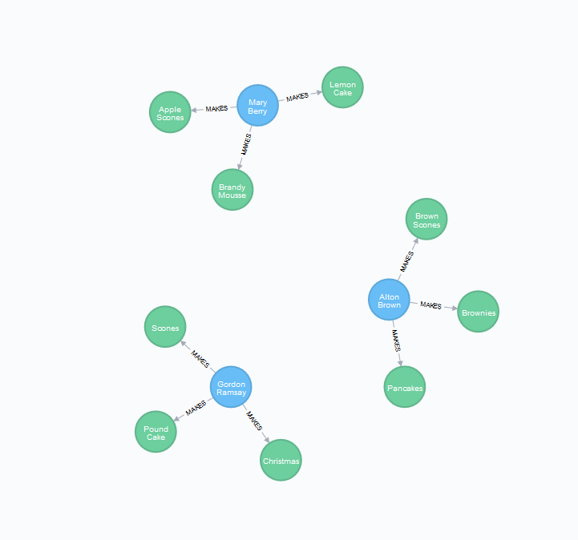

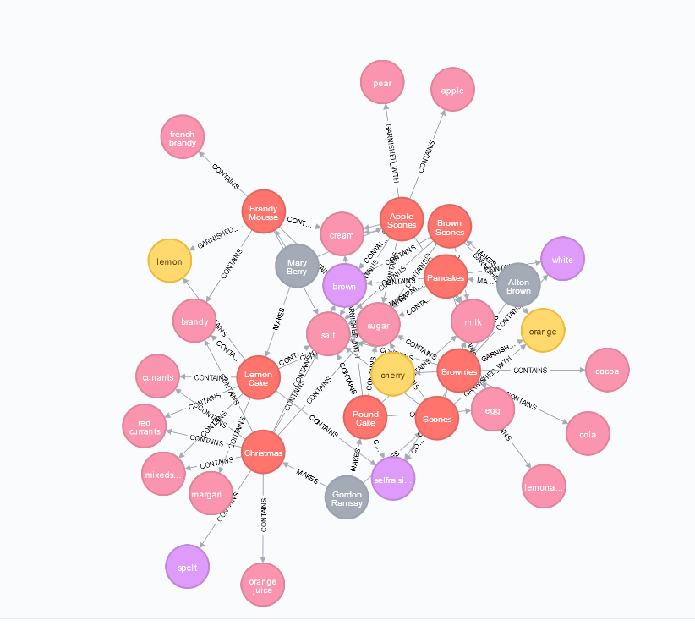

// Q2. List all of the cakes and the ingredients for each cake.

MATCH (c:Cake)-[r:CONTAINS]->(i)

RETURN c.name, i.name

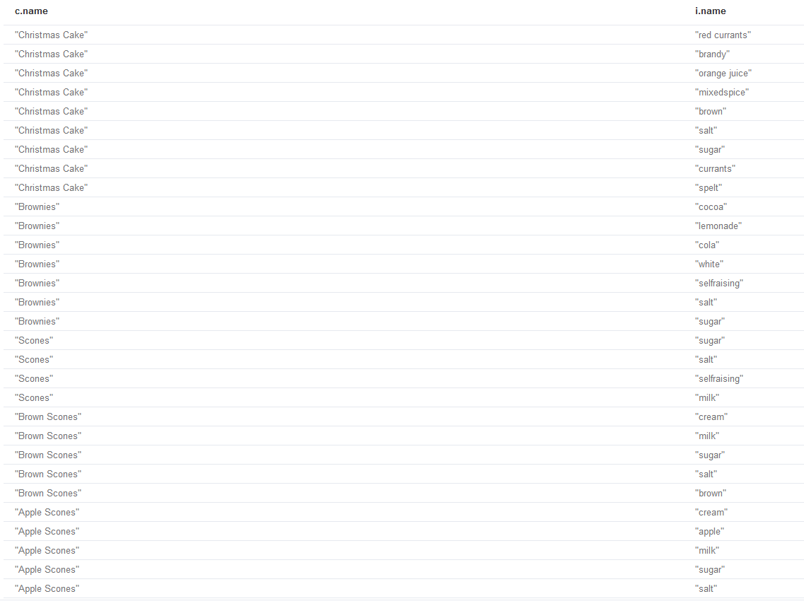

// Q3. List the ingredients in a brownie recipe.

MATCH (c:Cake{name:'Brownies'})-[r:CONTAINS]->(i)

RETURN c.name, i.name

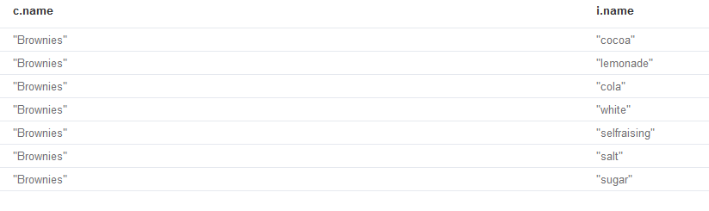

// Q4. List all the cakes with flour in them.

MATCH (c:Cake)-[r:CONTAINS]->(i:Flour)

RETURN c.name, i.name

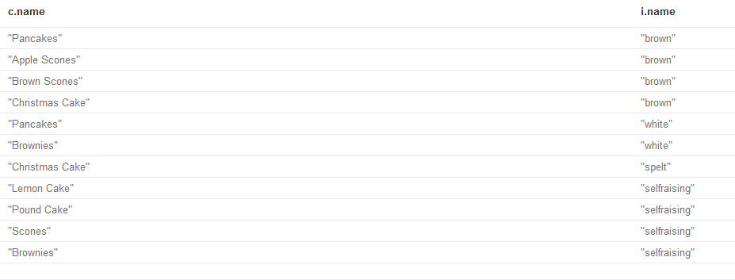

// Q5. List which Cakes have both Cream and Milk in them.

MATCH (c:Cake)-[r:CONTAINS]->(i:Ingredient)

WHERE i.name = 'cream' OR i.name = 'milk'

RETURN c.name, i.name

ORDER BY c.name

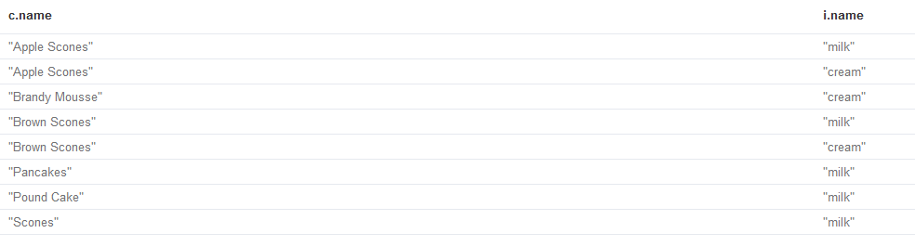

// Q6. List which recipes are associated with each chef.

MATCH (p:Chef)-[]->(c:Cake)

RETURN p.name, c.name

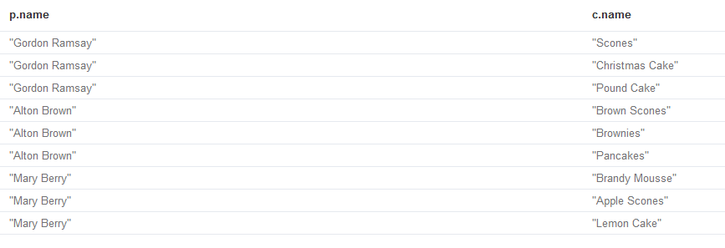

// Q7. What chef has the most popular recipes?

MATCH (p:Chef)-[q]->()

WHERE q.Popularity IS NOT NULL

RETURN p.name, q.Popularity

ORDER BY q.Popularity DESC

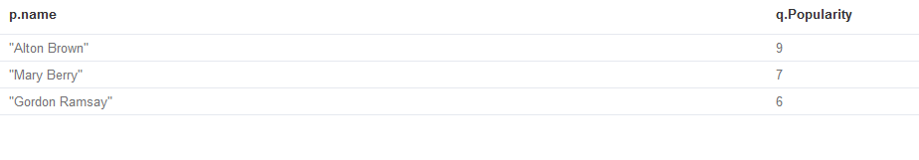

// Q8. What are the 5 most useful ingredients?

MATCH (c:Cake)-[r]->(i)

RETURN count(r) AS num, i.name

ORDER BY num DESC

LIMIT 5

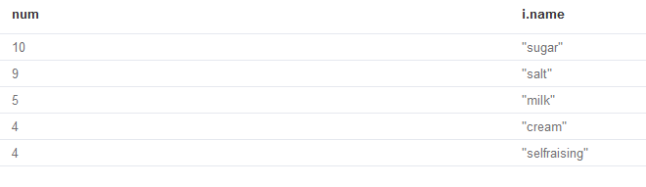

// Q9. What are the 5 least useful ingredients?

MATCH (c:Cake)-[r]->(i)

RETURN count(r) AS num, i.name

ORDER BY num

LIMIT 5

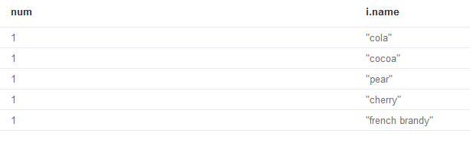

// Q10. What recipe is the most similar to apple scones - output list of ingredients from other recipes in order of similarity to this recipe?

MATCH (a:Cake{name:'Apple Scones'})-[r]->(b), (c:Cake)-[d]->(e)

WHERE b = e

RETURN a.name, c.name, count(r) AS num

ORDER BY num DESC

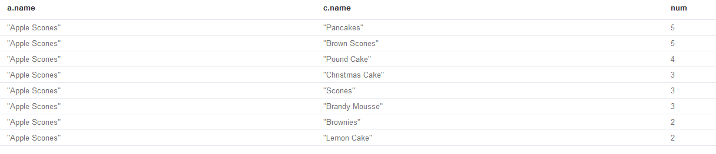

/* PART 3 */

// Q1. What kind of cuisine do New Yorkers prefer?

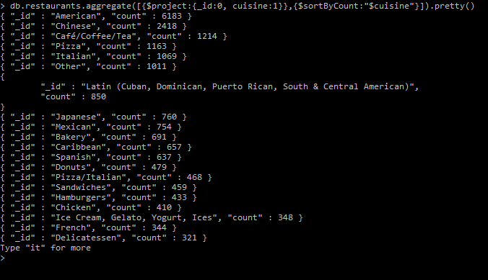

// Q2. Which area represents the biggest market opportunity for opening a new restaurant of this kind of cuisine?

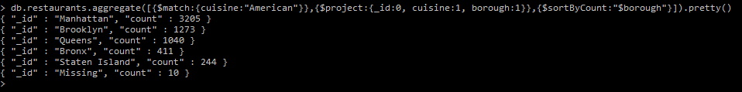

???



// Q3. Who are the biggest competitors in this area?

???